Mob Programming

Inland Empire .NET User Group Functional Layout

Davis DeBard

(909) 754-8404

12/22/13

Contents

1. Main Menu 3

2. Events 3

3. Speakers 4

4. Members 4

5. Sponsors 5

6. Prizes 5

7. Locations 5

8. Points 6

9. Data Schema 7

## Main Menu

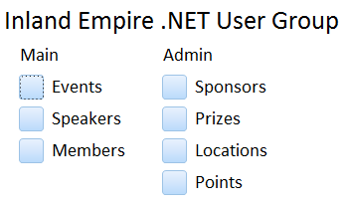

## Events

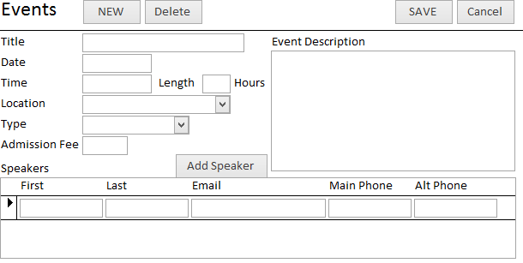

## Speakers

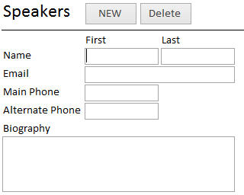

## Members

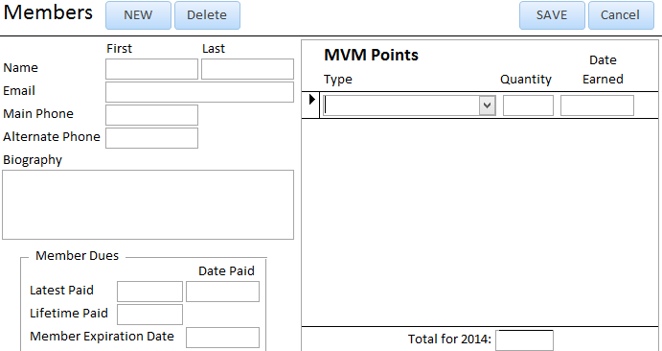

## Sponsors

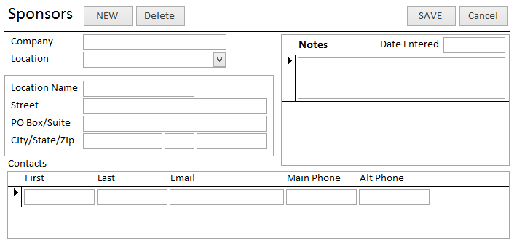

## Prizes

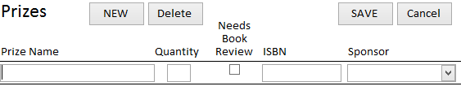

## Locations

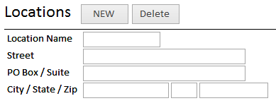

## Points

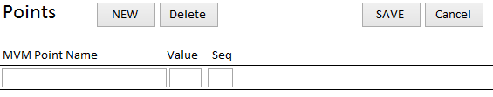

## Data Schema

